**Assignment Report**

**LAB SETUP**

**Kali Linux & Metasploitable 2**

Prepared by: Roshan.M.S.K

Date: 3/3/2024

**Executive Summary:**

The purpose of this report is to document the setup of a hacker lab, including the installation **of Kali Linux and Metasploitable 2** in virtualbox. The lab consists of two machine namely attacker machine (Linux) and a victim machine (Metasploitable 2). The report provides steps to create the setup. It is essential to note that this lab is intended for educational and testing purposes only, and ethical considerations should be taken into account while using it.

**Virtualbox installation:**

* **Go the search engine and search for virtualbox and download virtualbox for your OS.**

**KALI LINUX SETUP:**

**KALI LINUX ISO DOWNLOAD:**

* **Go to search engine and search for kali linux**
* select a Linux distribution that you want to install.
* Download the ISO image of the distribution from their respective websites.

**Create a New Virtual Machine:**

* Open VirtualBox.
* Click on the "New" button
* Enter a name for your virtual machine, select the type as "Linux," and choose the version that matches your Linux distribution
* Allocate the amount of RAM you want to assign to the virtual machine
* Create a virtual hard disk. Choose the default options unless you have specific requirements.

**Configure Virtual Machine Settings:**

* Select the virtual machine and click on “Settings”
* Under the "System" tab, make sure the boot order includes "Optical" before "Hard Disk."
* Under the "Storage" tab, click on the empty disk next to "Controller: IDE" or "Controller: SATA," then click the disk icon and choose "Choose a disk file."
* Browse to the Linux ISO you downloaded earlier.
* you can adjust other settings like network adapters, display, etc

**Install Linux:**

* Start the virtual machine by selecting it from the VirtualBox manager and click on the "Start" button
* The virtual machine will boot from the Linux ISO you attached.
* When prompted, select the option to install Linux, and follow the on-screen instructions to complete the installation process.
* After installation, the virtual machine will likely prompt you to restart. Go ahead and restart

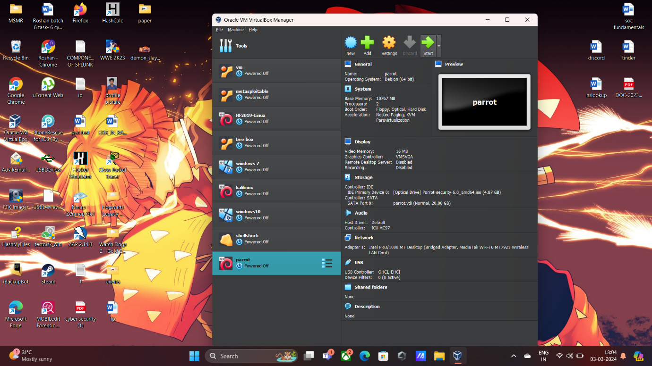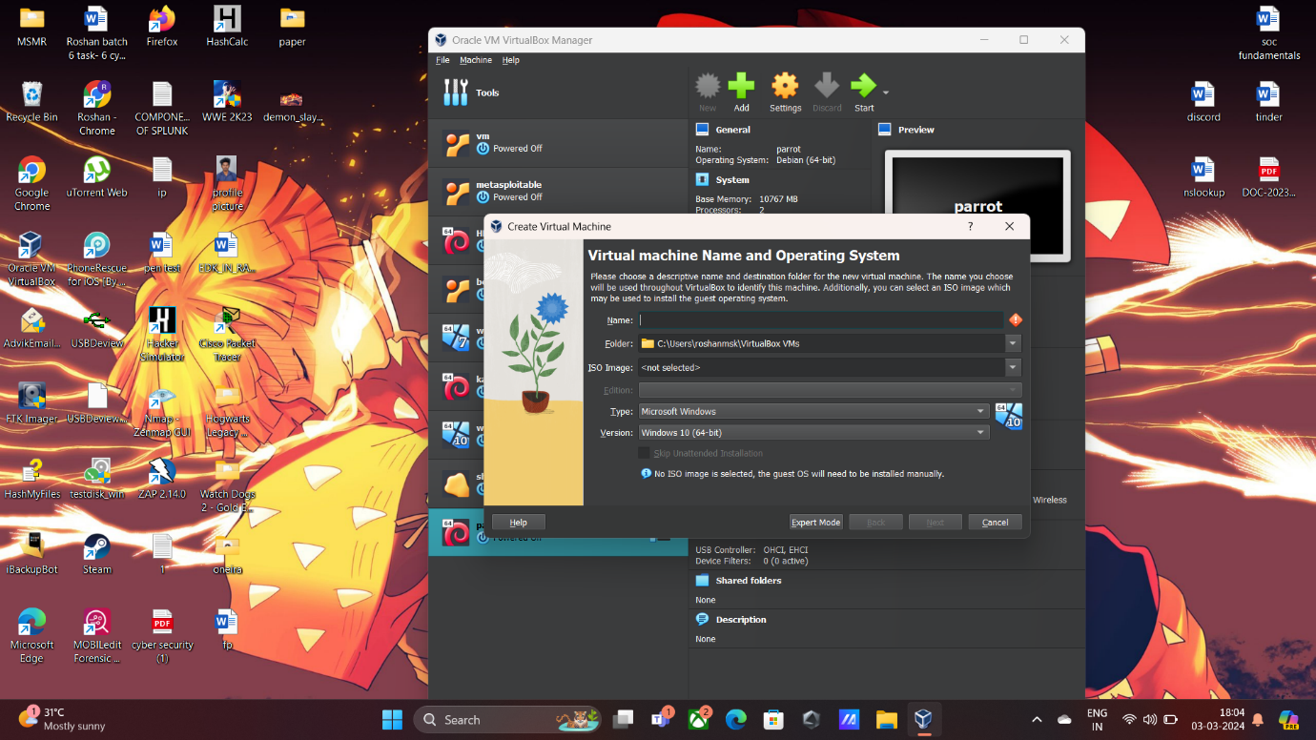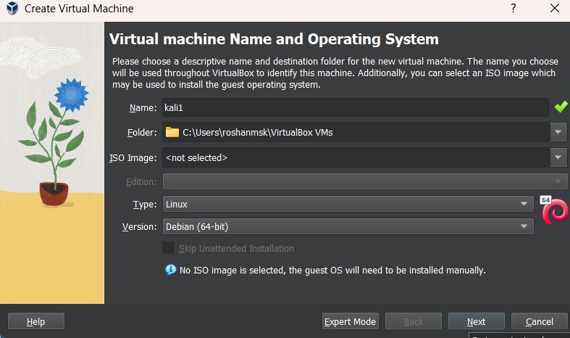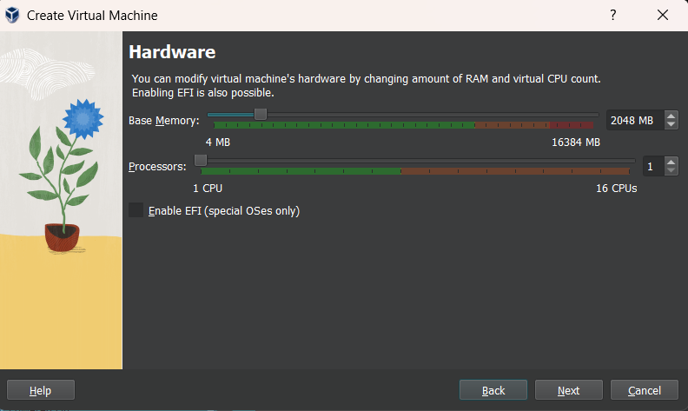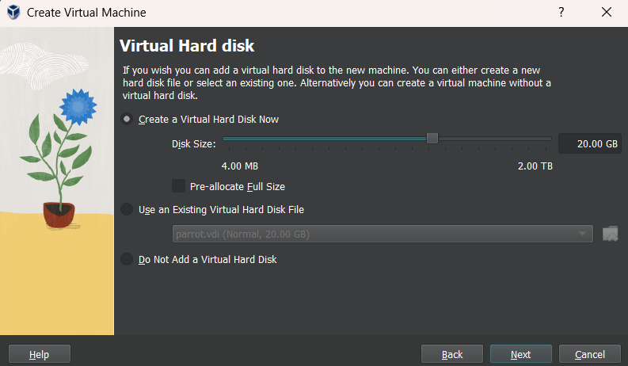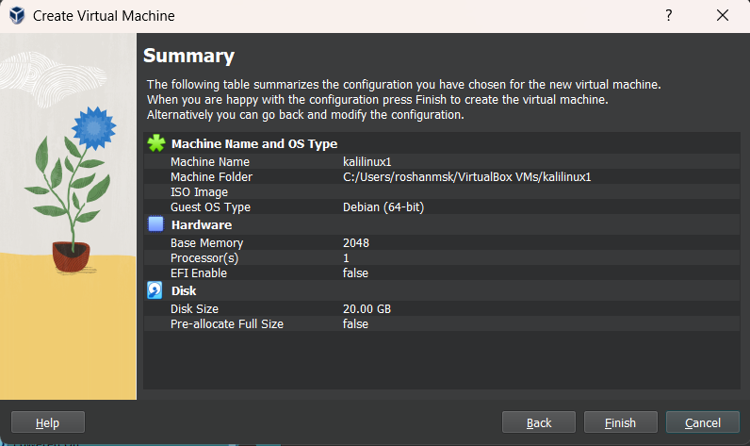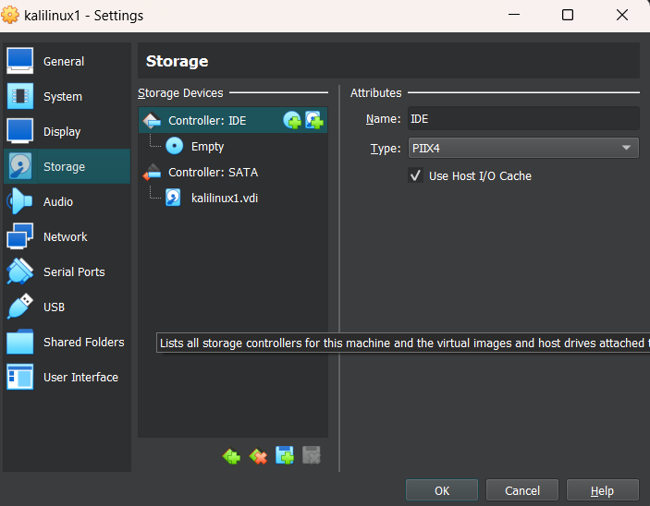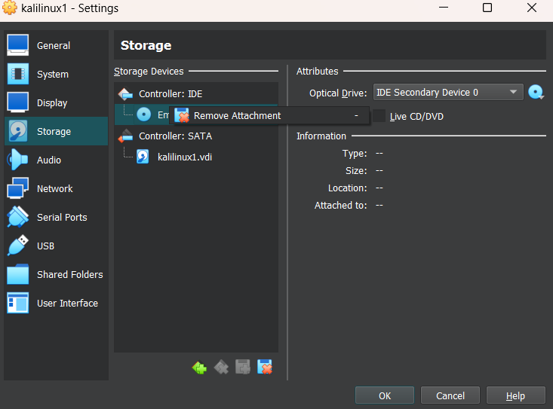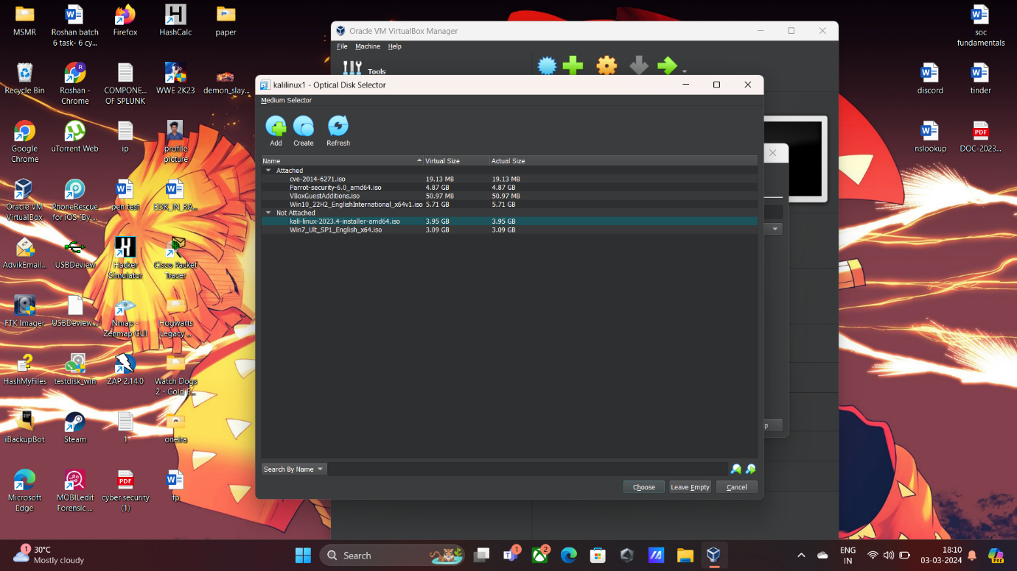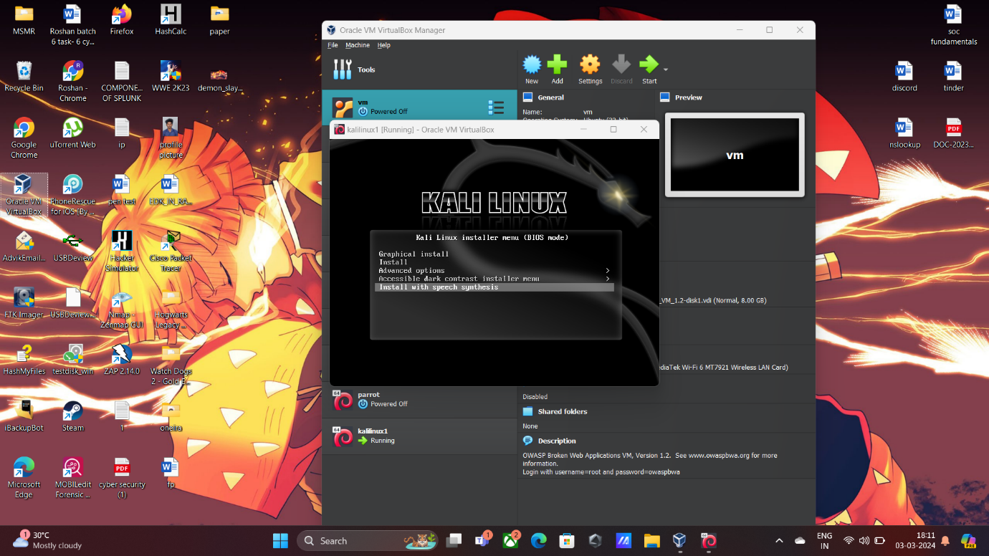

**METASPLOITABLE SETUP:**

**Download Metasploitable 2:**

* it from a trusted source. The file will typically be in OVA format, compatible with VM.

**Import Metasploitable 2 into VirtualBox:**

* Launch VirtualBox.
* Click "Next" and then "Import".

**Configure Metasploitable 2 VM:**

* select the newly imported VM in VirtualBox.
* Click on "Settings".
* Adjust settings if necessary, but you may adjust based on your system resources.
* Click "OK" to save the settings.

**Start Metasploitable 2 VM:**

* Select the Metasploitable 2 VM
* Click on the "Start" button

